

**Sunday, April 20, 2025 Volume 54 Number 16**

**The Most Important thing to preach:**

**The Resurrection of Christ**

**Text: 1 Corinthians 15:1–4**

Why is the resurrection of Jesus Christ important?

I.     The Resurrection of Christ _______________________________________________________.

II.   The Resurrection of Christ _______________________________________________________.

III.  The Resurrection of Christ _______________________________________________________.

IV.  The Resurrection of Christ _______________________________________________________.

V.     The Resurrection of Christ _______________________________________________________.

How will you respond to the resurrection of Jesus Christ?

**NORVAL PARK**

**CHURCH OF CHRIST**

**845 Arch Street**

**Zanesville, OH 43701**

**Office: (740) 452-2678**

**norvalparkcoc@gmail.com**

**www.norvalparkcoc.com**



***TONK TALK …***

**We Can Learn a Lot from Jesus’ Tomb**

The Etruscans were the first known inhabitants of Italy.  They were there before the Romans and had a highly developed civilization.  They left no written record, history, poetry, or literature.  All that we know of them we have learned from their tombs.

Archaeologists can learn a lot from the tombs of people and civilizations that no longer exist today, such as the Egyptians, Native Americans, and others.   Tombs of ancient people are often filled with jewelry, pottery, weapons, and even their idols.   They leave a trail of evidence and tell the story of people who can no longer speak.

As we came to worship this morning, I believe most of us passed a cemetery.  What do graveyards say?  What do we learn from those tombstones?

Regardless of the relics in the casket, the words on the tombstones, or the flowers decorating the grave.  They scream that life on planet Earth will not last.  Death is the one thing all humans have in common.  Heb. 9:27  states, “And just as it is appointed for man to die once, and after that comes judgment.”

But there is one tomb that speaks even louder than any other tomb in the world.  It has no relics, pottery, jewelry, or weapons.  It is empty.  Jesus’ tomb is void, bare, and vacant!  Yet it speaks volumes.  It shouts, “He is not here, for he has risen, as he said… (Mt. 28:6).   Jesus’ empty tomb teaches us that for the faithful Christian, their death is not final.  The grave is not the end, because He has defeated death and been raised from the grave (Acts 2:24).

Knowing the grave was not the end Jesus spoke these words in John 5:28-29, “Do not marvel at this, for an hour is coming when all who are in the tombs will hear his voice and come out, those who have done good to the resurrection of life, and those who have done evil to the resurrection of judgment.”

Unless Jesus comes back before we die, we will each be laid to rest in a tomb somewhere.

Question: Will your tomb proclaim a hopeless end or an endless hope? Think about it!

**In Christ’s Love, Mark T. Tonkery**

**DEACONS**

Matt Beardsley: 740-562-7561

Joe Henthorne: 740-487-8271

Donavon Jadwin: 740-252-1130

Joe Kennedy: 740-819-0025

Ben Lowe: 740-624-8088

Keith Shaner: 740-221-0196

Jim Sprague: 740-674-6988

Eric Wright: 740-819-9594

**ELDERS**

Gordon Brown: 740-319-2476

Paul Lowe: 740-455-3032

Jim Strouse: 740-453-9373

Donnie Watts: 740-819-3776

**MINISTER**

Mark Tonkery: 740-350-5713

**WORSHIP AND BIBLE CLASS**

**Sunday Bible Class ------------- 9:15 AM**

**Sunday AM Worship ---------- 10:15 AM**

**Sunday PM Worship ----------- 5:00 PM**

**Wednesday Bible Class ------- 7:00 PM**

**Where everyone is welcome!**

1. Joe Kennedy

2. Mark Allen

3. Bob Jones

4. Eli Milatovich

5. Jerry Kelly

**April 27, 2025**

**A.M. WORSHIP**

**Welcome:** Donnie Watts

**Song Leader:** Phil Shirer

**Prayer:** Jim Sprague

**Reading:** Frank Howell

**Sermon:** Mark Tonkery

**Officiating:** Joe Henthorne

**Dismissal:** John Beardsley

**Assisting at the Lord’s Table:**

**NURSERY ATTENDANTS**

**AM:** Brenda Beardsley

**AM Alternate:** Heather Carson

**APRIL GREETERS**

**AM Arch St:** Eric Fike

**AM Race St:** Tami Fike

**PM Arch St:** Tracy Baker

**P.M. WORSHIP**

**Song Leader:** Eric Wright

**Prayer:** Gordon Brown

**Reading:** Jensen Beardsley

**Sermon:** Mark Tonkery

**Officiating:** Jeff Jadwin

**Announcements:** Donnie Watts

**Dismissal:** Keith Shaner

1. Matt Beardsley

2. Ryan Bollinger Sr

3. Ryan Bollinger Jr

4. Jaxen Bollinger

5. Josh Loy

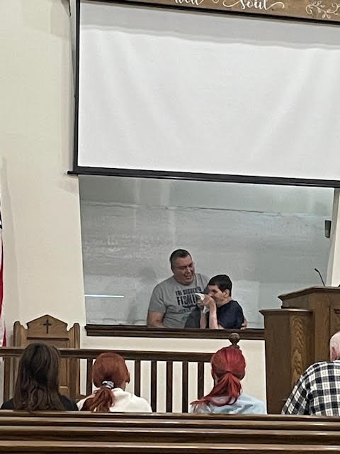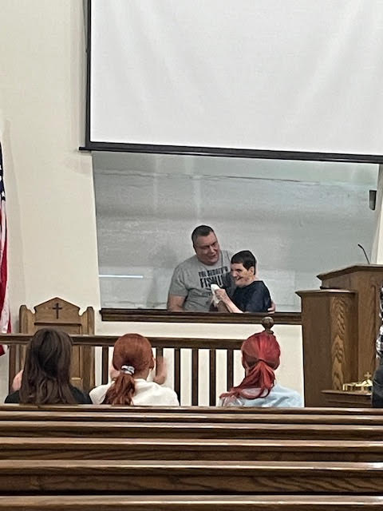*

**MOTHER/ DAUGHTER BANQUET**

Ladies mark your calendar for May 3rd, 2025, that will be the mother daughter banquet sponsored by Timothy Hill Ambassadors. It will start at 6pm at the church building, there will be dinner and dessert. Come enjoy a night of fellowship and good food. The men will be there to serve you dinner and to make your evening a little more special, it will be free to you. We ask that you sign up on the sheet on the bulletin board and put how many will be with you for the evening, please sign up by April 23. If you have any questions, please see one of the Ambassadors. **This is FREE for ALL Ladies!**

**THANK YOU**

Thank you to everyone who sent me Birthday cards.

-**Tony Seckman**

Thank you for all of the cards and prayers the past few months.

**-Tom Maxwell**

Thank you for all of the birthday cards and for all of the kind and encouraging words since becoming the secretary. I love you all.

**-Brenda Beardsley**

**DID YOU KNOW?**

New Facts:

* I had a near death experience in May 1974, Do you know who I am?
* I am a big eater. I need over 4500 calories every day. I always eat a lot of healthy foods, including fruits and vegetables. But the REALLY good thing is I can also enjoy my favorite sweet snack several times a day too---Peanut M&M’s!, Do you know who I am?

**WELCOME TO THE LORD’S CHURCH**

We joyfully announce that Debbie Atkinson obeyed the gospel and was baptized and added to the Lord’s Church on Wednesday, April 16, 2025; please join us in praying for, encouraging, and welcoming our new Sister in Christ.

**HELPING HANDS**

Helping hands is starting back up on Tuesday, April 22. If you have any questions please see Joyce Sprague.

**1.N.4.T.M.**

**ENCOURAGEMENT TEAM**

Encouragement Team from 1.N.4.T.M. or anyone who wants to send cards. Please meet Mark T. Tonkery next Sunday after morning worship (4/27/25) in the front of the auditorium.

**SPRING SING**

There is a Spring Sing at 7th Street Church of Christ in McConnelsville this Friday, April 25 from 7-9 PM.

**WELCOME ALL VISITORS**

Welcome to our church! We’re delighted to have you with us. Please fill out the blue card found on the back of the pew in front of you, and either return it in the offering basket or give it to one of the men. We thank you for coming.

**ANNIVERSARIES**

**April 21:** John and Barb Loy

**LADIES DAY AT SOMERSET**

Ladies Day at Somerset Church of Christ on

May 17, registration starts at 9:30. There is a sign-up sheet on the Bulletin board if you would like to go. Transportation will be provided. Speaker will be Erin Hittle-Smith.

Please see Kim Welsh with any questions.

**WEDNESDAY NIGHT BIBLE CLASS**

There is a sign-up sheet on the Bulletin board if you would like a copy of the new book that will start in June. If you have any questions please ask Paul Lowe. Thank You.

**MEMBER PICTURES**

All Members will be getting new pictures taken starting in May. Sign-up sheet on Bulletin board for which day you want your picture taken. If you would like your picture taken either Today or next Sunday, April 27, Please let Brenda know. Thank You.

**CVC CARDS**

CVC Cards are due back next Sunday, April 27. Any questions please see Jim Sprague.

**APRIL BOOK OF THE MONTH**

**JAMES:** When you complete the reading, please sign up on the Bulletin Board.

**PANTRY INFORMATION**

**Items Needed:** rice, instant potatoes & cans of evaporated milk

**Monday, April 21st:** Our pantry will be open to anyone in need from 3 to 5 PM.

**TODAY IN THE NURSERY**

**AM Service:** Barb Loy

**AM Alternate:** Molly Tharp Allen

**RECORD REPORTS**

Sunday, April 13 Bible Class ------------------- 104

Sunday, April 13 AM Worship ----------------- 162 Sunday, April 13 PM Worship ------------------ 57

Wednesday, April 9 Bible Class ---------------- 76

Sunday, April 13 Contribution --------------- 4591

2025 Average Contribution ------------------ 4910

2025 Baptisms --------------------------------------- 1

**BIRTHDAYS**

**April 23:** Linda Strouse

**April 24:** Vanessa Foster

**April 26:** Barb Chevalier

1. Kent McGee

2. Matt Milatovich

3. Rob Burrell

4. Judd Murvine

5. Eric Fike

1. Matt Beardsley

2. Nick Clark

3. Jensen Beardsley

4. Moses Ihinger

5. Phil Shirer



**Sunday, April 20, 2025**

**A.M. SERVICE**

**Welcome Donnie Watts**

**Song Leader Paul Lowe**

**535 The Glory-Land Way**

**560 Living By Faith**

**Prayer Jim Clegg**

**622 Ring Out the Message**

**1 Corinthians 15:1–4 Joe Kennedy**

**The Most Important thing to preach:**

**The Resurrection of Christ Mark Tonkery**

**943 Do You Know My Jesus?**

**113 His Grace Reaches Me**

**Communion Ben Lowe**

**Offering**

**Assisting at the Lord’s Table:**

**405 If Jesus Goes with Me**

**Dismissal Prayer Mark Allen**

**P.M. SERVICE**

**Song Leader Eric Wright**

**Prayer Daryl Hurst**

**James 2:1-9 Gary Carson**

**Saving Faith Mark Tonkery**

**Officiating Jim Sprague**

**Announcements Donnie Watts**

**Dismissal Prayer Jerry Kelly**

**Wednesday, April 23, 2025**

**BIBLE STUDY**

**Song Leader Mark Tonkery**

**Prayer Joe Henthorne**

**Devotional Jeff Jadwin**

**Announcements Donnie Watts**